Meira Strauss

09 Aug 2018

Abstract

Every website includes many parts and necessitates planning and thought for its creation. Besides for the content of the web page, the purpose, Graphical User Interface, programming languages and accessibility must also be considered to create a successful product. Website building incorporates multiple areas of computer science to create billions of web pages available all over the world.

How to build a website

Maalot Capstone – Senior Thesis

Table of Contents

Introduction 2

What is a Website? 2

Purposes of Websites 3

Social Networking 3

E-Commerce 4

Entertainment 4

Service-Based Business 5

Key Tips Necessary for all Websites 8

Focusing on the User 8

Content 8

Graphics 10

Refresh Content Often 11

Clear Navigation 12

Test the Website Thoroughly 13

Programming Languages 13

HTML 13

CSS 14

JavaScript 15

Web Stack 15

Operating System 16

Database 16

Web Server 17

Server Scripting Language 17

WAMP 18

Website Builders 18

Making the website public/ accessible 19

Web Hosting/ Servers 19

Domains 20

FTP 20

Conclusion 21

Glossary 23

Bibliography 24

# Introduction

## What is a Website?

The definition of a website according to Dictionary.com is “a connected group of pages on the World Wide Web regarded as a single entity, usually maintained by one person or organization and devoted to a single topic or several closely related topics” (Random House, Inc., 2018).[1] In other words, a website is a group of different pages on the internet made available to the public or to a group of people for a specific reason. There are many purposes for owning and upkeeping a website, and we will discuss these reasons further on.

Once a website is created, it must become accessible to users and must be constantly updated to keep track of new data, new styles, and new threats and vulnerabilities. The role of this paper is to explain the purpose of a website, the way it is programmed and created, and the way it becomes available on a network.

There are many different aspects that go into the creation of a website. Many factors affect the content, graphics, and ease of use. An entertainment or social media website will have a lot more exciting colors than a website advertising funeral homes. An educational website for college students will have many more words than a website selling children’s toys. Because of the huge range of possible websites and criteria for the website, we will be focusing on the criteria and building of a law firm’s website. This website will be built for external purposes causing it to be an outward facing website as opposed to an inward facing website which is created for the sole use of the office. We will call the website from here on in “The Law Firm Website.”

# Purposes of Websites

Determining the purpose of the website is the first vital step in its creation. Because there are so many different uses of a website and these different objectives can be mixed together, one must set a goal for the website and always keep the goal in mind, if he or she wants the website to be successful.

According to WorldWideWebSize.com, there were over fifty-two billion webpages on the World Wide Web in July of 2018 (Kunder, 2018). There are so many websites on the internet today, and each one is there for a reason. The purpose for most websites falls into a few main categories. Websites are created for social networking, e-commerce, entertainment, information, and service-based business websites.

## Social Networking

A social networking website’s goal is to help people connect and share with each other. The users of a social networking website can be businesses, kids, family members, and anyone who wants to contact other people. The way a social networking website achieves its intent, is by allowing users to easily contact other people, view their profiles, and share information about themselves (D'Ambra, 2018). [2]

## E-Commerce

The term E-Commerce stands for Electronic Commerce which is the term used to refer to “the buying and selling of goods and services, or the transmitting of funds or data, over an electronic network, primarily the internet” (Rose, 2018).[3] This type of website must keep track of the inventory, paying methods and information, and security of all personal data. The goal of an e-commerce website is to effectively portray and sell its products. The security of sensitive data, and data integrity is also a major concern of e-commerce websites. Sensitive data includes PII, Personally Identifiable Information like name, address, social security number, phone number and can also include PCI, Payment Card Information like Credit Card numbers. All this information must be protected by the e-commerce websites and is a big part of the e-commerce website’s goal.

## Entertainment

The purpose of an entertainment website is to give pleasure and occupy the users. Entertainment websites include websites with games, movies, funny comics etc. Many entertainment websites try to earn money through their entertainment. These websites might charge businesses for hosting the business’s advertisements on the entertainment site or charge a membership fee to users.

## Service-Based Business

The Law Firm Website falls under the category of service- based business websites, therefore, we will discuss in detail the goals and requirements for this specific type of website.

A Service-Based Business website’s goal is for the consumer to learn about a business and its services and to be convinced to use this business for his or her needs. Before using a business, service, or store, many consumers look at the business’s website to gain certain information, including; experience, reliability, credentials, reviews from past clients, etc. This can help the user determine if he would like to use the service or refer the service to a friend. In addition, many people will “query” the internet to find a service provider that they may need and compare the different companies that are the results of his search. For these reasons, it is very important for all businesses, both small and large, to have a functional and informative website.

Along with all other service-based business websites, a website for a law office must ensure effectiveness and ease of use. The website must have a clearly defined goal that is understood by the potential consumer. The goal of all service-based business websites is to show the advantages of using the company that is portrayed. Therefore, the role of the business and what the business can provide must be obvious to anyone opening the website. In addition, the most important pieces of information on this type of website is the contact information which must be easy to get to and clear so that the consumer will take the next step and contact the business (Steiner, 2010).[4]

The Law Firm Website is created with the purpose of attracting and informing clients. Because this is the goal, the website contains a page reflecting all the employees’ credentials and experience.

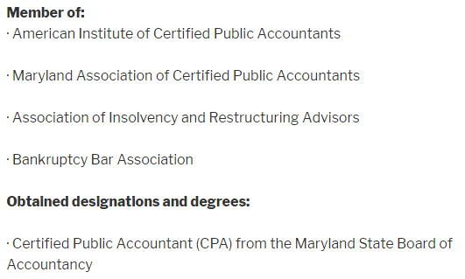

Another important page cites the Head Lawyer and Accountant Larry’s articles, speeches, and seminars. The article headings are linked to the articles themselves to allow website users to preview the publications.

Finally, there is a page listing past bankruptcy cases of the company.

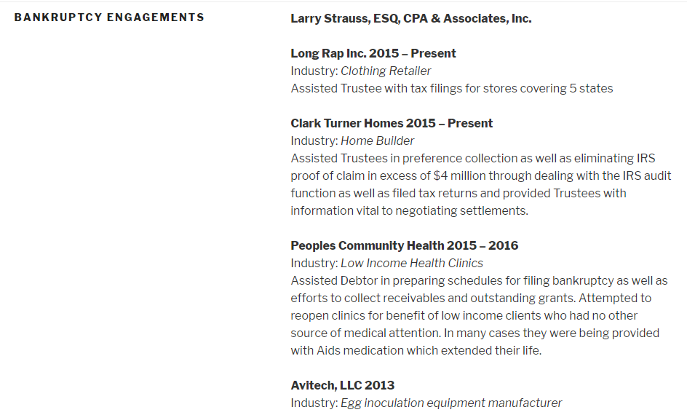

These pages prove the abilities and expertise of the company and will help attract new clients. Because we know the purpose and goal of this website, we can tailor the website to include pages that will interest and appeal to more clients and increase the publicity of the company.

Some businesses would like to use their websites to help their current clients as well as potential clients. Specifically, a law office may have a portal to upload files and a form to ask questions. This interaction with the client adds professionalism and quality to the business, but a website which offers dynamic interaction with the client must be extra careful of security on its website because most client personal information is private.

Once the purpose of the website and the content that should be included on the website have been established, the creation of the website can begin.

# Key Tips Necessary for all Websites

The actual creation of a website is a multi-step process including many different parts. There are also many different aspects that must be kept in mind during creation. To have a purpose and general content is not enough to build a successful website. To build the website, one must identify the users and cater the website toward their needs. In addition, one must keep the website’s information current and relevant, include clear navigation, and test the website for errors.

## Focusing on the User

All websites and applications are created to be used. When programmers and developers build new applications, they must create with the knowledge that other people are the ones who are going to be using the program. Web developers must program assuming, that the user doesn’t know anything about the information conveyed or how to navigate the site. Nothing is obvious to the user! The builder must predict the prospective audiences’ age, gender, and computer abilities. This will affect all different aspects of the website including content and graphics.

### Content

The information that all possible users are looking for must be available on the page. All links and information should be up to date. For example, if the website is for a college, the college should have updated information for all the possible users of the website which may include current and potential students, current and potential professors, and other staff members of the institution. The content of this type of website must be constantly updated based on current schedules and policies.

For The Law Firm Website, the content must be edited based on the possible users as well. For this specific website, we will be catering mainly toward potential clients of the firm. Therefore, we will include the following pages; about us, services, publications, and contact information. The purpose of “about us” is to introduce the possible user to the law firm. The “services” will explain the different services that the firm offers. “Bankruptcy Engagements” refers to previous cases which the firm has resolved. The “publications” page will show links to different papers and articles that the lawyer has published. This page will prove the experience and expertise of the lawyer. Finally, the “contact us” page will have a list of all the staff in the law office, their position and how to contact them. The “contact us” page is extremely important because this allows the firm to gain more clients which is one of the main purposes of the site.

One must always consider the possibility that the user will have some type of disability, and therefore allow for alternate methods of use. For example, if a blind person is using the website, your website must allow for screen readers, voice interactions and-or contain alternate text for all the images.

Alternate texts are important also because of possible malfunctions or older versions of computers. If the user’s computer can’t upload a picture from the website’s host server, the alternate text will display so the user can see what the picture represents. Allowing for different options for possibly users with disabilities is very important for our website because lawyers are often used by people with disabilities. Especially if this specific office deals with disability cases, the website must cater to people with disabilities.

### Graphics

The graphics of a website are extremely important despite what many people think. If a user opens a website that has pink letters on an orange background, he or she will most likely close the page because it is very hard to read and unpleasant to look at. This applies for many color combinations. In addition, a website for teenagers’ entertainment should look a lot more colorful and exciting than a website for an old age home. Because the users of these two types of website are different, the graphics too will look very different.

The old age home’s graphics should look sophisticated and professional to please both older aged users as well as their children or guardian who might also be looking at the website. The colors should be dark, and the words should be big to allow for people who are losing their sight to still see the words on the screen. In addition, the old age home can show a few pictures of current clients to show what life looks like in the old age home. This will hopefully bring a homey and friendly look to the nursing home to attract potential clients to the home.

In contrast, when creating a website for teenagers the graphics should be colorful and modern. There is no need for the words to be extra-large or for the words to be dark, because teenagers usually see fine. In addition, this website may contain many pictures changing constantly to attract the teens. This will excite the teenagers and keep them on the site. But, to have pictures of people in an old age home, will not attract the teenagers at all, unlike the old age home’s website which will include many pictures of that sort.

The Law Firm Website will look more like the old age home website because of the users that it is catering toward. Usually, the clients of a law office are adults looking for information, not excitement. Therefore, the graphics will be simple and elegant to attract a sophisticated and polished clientele. There will be very few pictures, and they will be simple, and work related; no surprises or flashy colors.



By formatting a website based on who the users are, you can make the website pleasing and attractive for the clientele the website is catering to. This will keep the users happy and satisfied and able to find the information they want.

## Refresh Content Often

All Users looking at a website want to know the most up to date information possible. For all the data on a website to be accurate, the website must be updated as often as necessary. Some websites work on real-time. This means that the website is constantly updated every second or millisecond. Some are updated every hour like weather sites, while others are updated once a day or once a week like college web sites. The Law Firm Website will not need to be updated so often, only when information changes. Possible changes can include new or retired employees, new cases, or a new publication.

In addition to ensuring current content of the webpages, the graphics of a website must also be refreshed and changed based on the latest styles and technologies.

## Clear Navigation

In addition to the content and graphics, the website’s links and menu options should be easy to navigate so the user can find the information that he wants to see. Very often, a website is available containing all the information a user is seeking, but the user can’t find the specific information he wants because the navigation is unclear! Many times, the user can get frustrated and upset. One very important thing to have on all websites to aid the user in his navigation and search of the website is a menu bar on all pages. In addition, all information and pages should be kept in clear categories.

For The Law Firm’s Website, we will have a menu bar in the header to help the user navigate the pages. The menu bar will include all the pages in our website. This bar will appear on every page so that the user can easily switch from page to page. In addition, the “About” category includes both the “About” page and “Services” page to categorize the pages for clarity.



## Test the Website Thoroughly

One important way to determine the correct graphics, content, and navigation, is through testing of the program. Often, a prototype or sample of the webpage is created and “tested” on possible users to determine ideal graphics, positioning, content, etc. of the websites information. In addition, the final step in the creation of every type of computer program is testing. Throughout a program’s development and specifically before it is deployed, testing must be performed to assure that there are no issues or problems with the program.

After the planning and design steps are completed, a developer can begin to create the actual website using programming languages.

# Programming Languages

How do you create a web page? What languages do you use? A simple web page can be written with plain text alone! Most web developers want more than just text, so the most common website language to create the content of a webpage with basic formatting is called HTML. In addition, to enhance the webpage with more complex styling, CSS is used. Finally, to create a dynamic web page that reacts and responds to different movements and stimuli, you can use JavaScript.

## HTML

The content of every webpage is created with code called HTML. HTML stands for Hypertext Markup Language referring to the links that HTML supports and the markup tags that surround all the text of HTML code to format it (SphinxKnight, 2018).[5] All the information in our law website will be contained in HTML tags. For example, on the Contact page, the names of all the employees are surrounded by <strong> tags to make them appear bold on the page, and the email addresses are surrounded by <a> tags to allow the email addresses to be able to be clicked and forward you to a new page to email the chosen staff member.

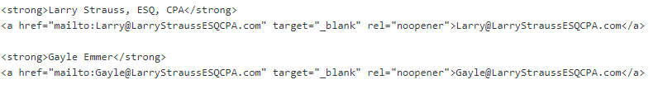

## CSS

The term CSS stands for Cascading Style Sheets. These sheets otherwise known as CSS code controls all the complex styling of a website. This styling can be imbedded into the HTML of the web page. Alternatively, if there is a lot of CSS coding, the CSS reference can be linked to the HTML code using a HTML <link> tag. HTML tags are automatically formatted a specific way, but you can use CSS to change the formatting to what the client specifically wants. For our website, we can say in our CSS that all words contained in the <a> tags should have a transparent background color and when you click the words contained in the <a> tag or hover over it, there should be a 0-outline width (Haydon, 2018).[6]

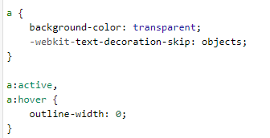

## JavaScript

The functionality of a webpage is created through JavaScript code. JavaScript makes a web page dynamic as opposed to static. Because this functionality is executed by the browser, the execution of the code is both fast and efficient. JavaScript code can be performed after leaving a text box or clicking on a word. We can use JavaScript in our website to tell the client that he did not fill in all relevant information in a contact/ request form to the lawyer.

Once the coding of the webpage is completed, some important applications must be downloaded to view the website using a browser.

# Web Stack

There are four main components of all major websites that allow websites to run. These components are part of the website’s Web Development Stack and include an operating system, database, web server, and web scripting language (Beal, WAMP, 2018).[7] There are also some stack packages which allow a client to download all parts of the stack at one time. Each essential part of the stack will be discussed as well as an example of a stack package which The Law Firm Website used to create its website.

## Operating System

An operating system is the most important part of a computer system. The Operating System or OS of a computer is the program that runs and manages all the other programs or applications on the computer (Rouse, 2016).[8] This includes interpreting the hardware and the software, keeping track of different programs to make sure they don’t affect each other, and keeping track of security of the data on the computer (Beal, operating system - OS, 2018).[9] The top four most popular operating systems today include; Windows, Linux, Unix, and iOS. The Law Firm Website will be written on Windows operating system but will be compatible for all operating systems.

Most operating systems include text editors and web browser which are necessary in creating, editing, and viewing web pages. The purpose of the text editor in web development, is that it allows the user to edit plain text files without adding in extra formatting (Text-Editor.org, 2010).[10] To create a basic website, all you need is a basic text editor. To view the web page that you create with the text editor, run the text file on a web browser which interprets the text file, and allows the file to be viewed.

## Database

The purpose of a database in web development is to store the data for the website. Most websites produce some type of data that needs to be kept for reference or functionality. Types of databases include relational and non-relational. Some popular database systems are MySQL (relational), PostgreSQL (relational), and MongoDB (non-relational) (Gleb & Vlad, 2011-2018).[11] A possible example of the use of a database for The Law Firm Website is storing usernames and passwords for users to log-in.

## Web Server

The purpose of a web server is to hold the website’s files and deliver them to the client upon request (Art, 2010).[12] Every website is hosted on a web server which then responds to the client request to see the website and returns the website’s code to the browser to translate. This is the way website can be seen by the client.

## Server Scripting Language

In addition to all the other necessary parts of the stack, a server scripting language is essential to create the webpage. A server scripting language allows for server coding and interpretations. Possible server scripting language options are Perl, Python, and PHP. The Law Firm Website uses PHP for its server scripting language. The JavaScript coding previously mentioned can have a similar effect to the PHP, but these languages are very different. The difference between JavaScript and PHP is that PHP is a server-side language while JavaScript is client side. JavaScript makes a webpage dynamic as opposed to static, while PHP is imbedded into the HTML and causes actions to be done on the server. The advantage of JavaScript is that it is executed immediately on the browser. This is unlike PHP which waits for a call to the server to execute (Guru99, 2018). [13]

## WAMP

There are ways to download all the tools needed for a database at one time. WAMP is an open source set of applications that allows the user to download on a Windows operating systems (W), Apache Tomcat for the web server (A), MySQL for the database (M), and Python or Perl or PHP for the web scripting language (P). This is an extremely valuable tool because it allows for the download of all the vital components in one step. The Law Firm Website used the WAMP stack to develop and view its website.

A web hosting service can provide these important elements, but if one would like to create a website on his own PC then he will need to download his own Web Stack and tools so the website can run.

## Website Builders

Throughout the evolution of computers and software, multiple tools and programs for shortcuts have been built. One type of program which has become very useful for all developers as well as non-developers is website builders. These builders allow the user to create a website using a GUI interface which writes the HTML and the tags for the user in the back-end! By using this type of tool, developers save time from typing in the code. Also, non-developers can create websites without any programming knowledge. These website builder technologies have also evolved over time with more advanced programs being developed and created. Dreamweaver, WordPress, and Jekyll are all examples of different popular website builders. The Law Firm Website using WordPress because it allows for multiple types of websites and information as well as includes plug-ins to add any functionality a user would want. In addition, WordPress is open-source which accommodates for easy editing to the actual code (Blake, 2018).[14] By using WordPress, the developer does not need to spend time on the simple coding, and therefore he or she can immediately focus on personalizing and editing his website for a professional, unique look.

# Making the website public/ accessible

Once the website is prepared and ready to be made available on the web, the website must be placed on a web server to allow public access. In addition, the website must have a domain name and IP address to allow the website to be previewed after typing it in to a browser’s search window.

## Web Hosting/ Servers

There are many different web hosting companies available. Each one will vary on the expense, amount of space available for each website, and other components. GoDaddy, HostGator, 1and1, and Wix.com are all examples of web hosting companies online. Each one has benefits, but The Law Office chose HostGator because of it’s relatively cheap price. There is usually a monthly fee for web hosting that can really add up to a lot of money with an expensive plan. Many web hosting companies will also offer other benefits like website builders or company email accounts. These website builders are good, but not nearly as advanced as a website builder like WordPress.

## Domains

Every device and website have a name to allow devices to communicate with each other. This name is a set of numbers called an IP address. If the IP address of a website is placed in the browser window, the browser will go to the location of the website, receive the information and data, and send a copy of the website back to the browser. The problem is, that an IP address is hard to remember. It’s just a set of random numbers separated by periods or colons. To solve this issue of ease of use and memory, the DNS or Domain Name Server was created. The DNS keeps track of IP addresses and the names associated with them. For example, if the IP address of The Law Website is 197.68.456.4, but we set the domain name to be [www.larrystraussesq](http://www.larrystraussesq).site, when the user types in the domain name, the browser will first go to the DNS and find the IP address (197.68.456.4) for this domain name. After the browser finds the IP address, it can then easily go to the location of the website using the IP address.

Therefore, another tool needed to build the website online and allow access to it from the world wide web, is to buy and assign a domain name to the website. This will be the website’s name, and the words that a client will type in to the browser window to find the website. It should be something easy to remember so users don’t have difficulties finding the website. This domain will be associated with the IP address. The domain name for The Law Firm Website will be [www.larrystraussesq](http://www.larrystraussesq).site.

## FTP

Finally, the last step in allowing public access to the website, is transferring the website’s files to the web hosting service. The transferring of the files can be done using a process called FTP, File Transfer Protocol. An FTP program must be downloaded on the computer which currently has all the files and documents for the website, and then the files can be moved to the new hosting. One must always back-up and make a copy of his or her files before performing a transfer as not to lose any data. In case a mistake is made, the copy will allow the user to retain all the information.

# Conclusion

Proper creation of a website involves preparation, knowledge of website coding languages, and necessitates acquiring proper tools. Although it is extremely easy to make a simple HTML document and call it a “web page,” to make a more multifaceted dynamic webpage and allow public access to it is a lot more complex.

By following the steps mentioned above, a person’s website will become a success. Determine the purpose and design the website keeping the goal in mind. Focus the content and graphics on the relevant users and refresh the website’s information often. Finally, other essentials for every website include clear navigation and thorough testing of the website.

To program a webpage, HTML, CSS, and JavaScript are used. Once the webpage is built, a web stack is necessary to run the new program. This stack includes an operating system, a database, a web server, and a server scripting language. Website Builders can be used to write the coding for a client, and some applications allow for complete downloads of web server stacks (WAMP). Finally, to allow public access to the completed webpage, the webpage content must be transferred to a web host.

In conclusion, by following a set list of instructions, anyone can create a website that is informative, usable, and pleasant to look at.

# Glossary

|  |  |
| --- | --- |
| CSS | Cascading Style Sheet - Computer Language used to style the HTML |
| DNS | Domain Name Service - Matches Domains to IP addresses |
| Domain | Name assigned to a device or web page |
| E-Commerce | Electronic Commerce - Conducting business over the internet |
| FTP | File Transfer Protocol - Protocol for sending data from one device to another |
| HTML | Hyper Text Markup Language - computer language to write web pages |
| IP Address | Set of numbers to identify a device |
| Java Script | Computer Language run by the browser which allows the website to be interactive and dynamic |
| Open-Source | Back-end code is accessible to the user |
| PHP | Computer Language run by the server which allows the website to be interactive and dynamic |
| Query | Request information from a server or servers |
| Web Hosting | Company that supports web pages on a server to allow access to the page from the internet |
| Web Stack | Essential Components to run a website |
| Website | Group of pages on the available on the internet |

# Bibliography

Art. (2010, August 23). *What Are Web Servers and Why Are They Needed?* Retrieved from Web Hosting Geeks: https://webhostinggeeks.com/blog/what-are-web-servers-and-why-are-they-needed/

Beal, V. (2018). *operating system - OS*. Retrieved from webopedia: https://www.webopedia.com/TERM/O/operating_system.html

Beal, V. (2018). *WAMP*. Retrieved from webopedia: https://www.webopedia.com/TERM/W/WAMP.html

Blake, G. (2018, June 16). *Which One, Dreamweaver Or WordPress?* Retrieved from Ten Ton: https://tentononline.com/should-you-be-using-dreamweaver-or-wordpress/

D'Ambra, S. (2018). *What is the Purpose of a Website?* Retrieved from ClearTech Interactive: https://www.cleart.com/what-is-the-purpose-of-a-website.html

Gleb, B., & Vlad, V. (2011-2018). *How to Choose a Technology Stack for Web Application Development*. Retrieved from RubyGarage: https://rubygarage.org/blog/technology-stack-for-web-development

Guru99. (2018). *PHP vs JavaScript: Must Know Differences*. Retrieved from Guru99: https://www.guru99.com/php-vs-javascript.html

Haydon, J. (2018). *What's the Difference Between CSS, HTML and PHP?* Retrieved from John Haydon: https://www.johnhaydon.com/whats-difference-between-css-html-php/

Kunder, M. d. (2018). *The Size of the World Wide Web (The Internet)*. Retrieved from WorldWideWebSize.com: http://www.worldwidewebsize.com/

Random House, Inc. (2018). *Website*. Retrieved from Dictionary.com: https://www.dictionary.com/browse/website?s=t

Rose, M. (2018, June). *e-commerce*. Retrieved from TechTarget: https://searchcio.techtarget.com/definition/e-commerce

Rouse, M. (2016, September). *operating system (OS)*. Retrieved from WhatIs.com: https://whatis.techtarget.com/definition/operating-system-OS

SphinxKnight. (2018, July 11). *HTML: HyperText Markup Language*. Retrieved from MDN web docs: https://developer.mozilla.org/en-US/docs/Web/HTML

Steiner, C. (2010, March 24). *Top Tips: 10 Elements Of Any Effective Web Site*. Retrieved from Forbes: https://www.forbes.com/2010/03/24/web-site-design-entrepreneurs-technology-tips_slide.html

Text-Editor.org. (2010). *What is a Text Editor?* Retrieved from Text-Editor.org: http://www.text-editor.org/

1. Dictionary.com
2. https://www.cleart.com/what-is-the-purpose-of-a-website.html
3. https://searchcio.techtarget.com/definition/e-commerce
4. https://www.forbes.com/2010/03/24/web-site-design-entrepreneurs-technology-tips_slide.html
5. https://developer.mozilla.org/en-US/docs/Web/HTML
6. https://www.johnhaydon.com/whats-difference-between-css-html-php/
7. https://www.webopedia.com/TERM/W/WAMP.html
8. https://whatis.techtarget.com/definition/operating-system-OS
9. https://www.webopedia.com/TERM/O/operating_system.html
10. http://www.text-editor.org/
11. https://rubygarage.org/blog/technology-stack-for-web-development
12. https://webhostinggeeks.com/blog/what-are-web-servers-and-why-are-they-needed/
13. https://www.guru99.com/php-vs-javascript.html
14. https://tentononline.com/should-you-be-using-dreamweaver-or-wordpress/